**Sir Syed CASE Institute of Technology**



Lab # 06

**CS1001L - Programming Fundamental**

Submitted by: **Shawaiz Saleem**

Roll No. : **2430-0096**

Class Section: **BS-CS**

“On my honor, as student of Sir Syed CASE Institute Islamabad, I have neither given nor received unauthorized assistance on this academic work.”

Submitted to:

**Sir Bilal Dar**

DATE:

**2nd Nov. 2024**

**Task 1:**

Write a C++ program that will print the following pattern.

**Code:**

|  |
| --- |
| #include<iostream>  using namespace std;  int main()  {  for(int i=1;i<=7;i++)  {  for(int j=1;j<=i;j++)  {  cout<<"*";  }  cout<<endl;  }  } |

**Output:**

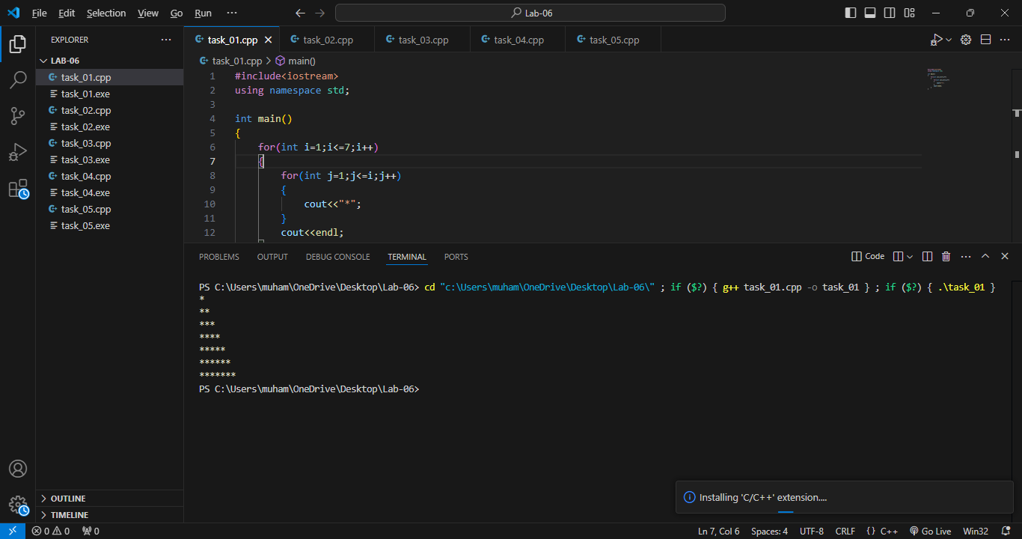

**Task 2:**

Write a program to print a pyramid pattern with numbers where each row has incrementally increasing numbers.

**Code:**

|  |
| --- |
| #include<iostream>  using namespace std;  int main()  {  for(int i=1;i<=5;i++)  {  for(int j=1;j<=i;j++)  {  cout<<j;  }  cout<<endl;  }  } |

**Output:**

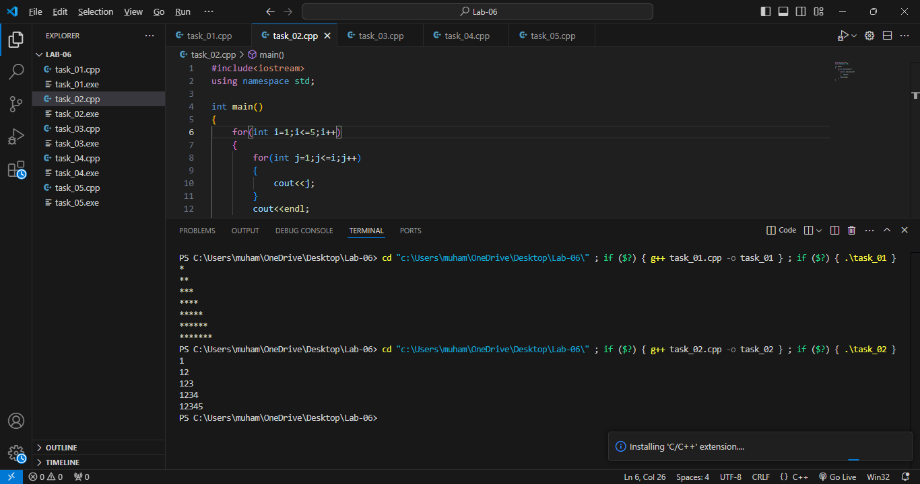

**Task 3:**

Write a program in C++ to print a pattern based on a user-input number of rows. The pattern should display increasing rows where each row i contains the integer i repeated i times.

**Code:**

|  |
| --- |
| #include<iostream>  using namespace std;  int main()  {  int rows;  cout<<" Enter number of rows:- ";  cin>>rows;  for(int i=1;i<=rows;i++)  {  for(int j=1;j<=i;j++)  {  cout<<j<<" " ;  }  cout<<endl;  }  } |

**Output:**

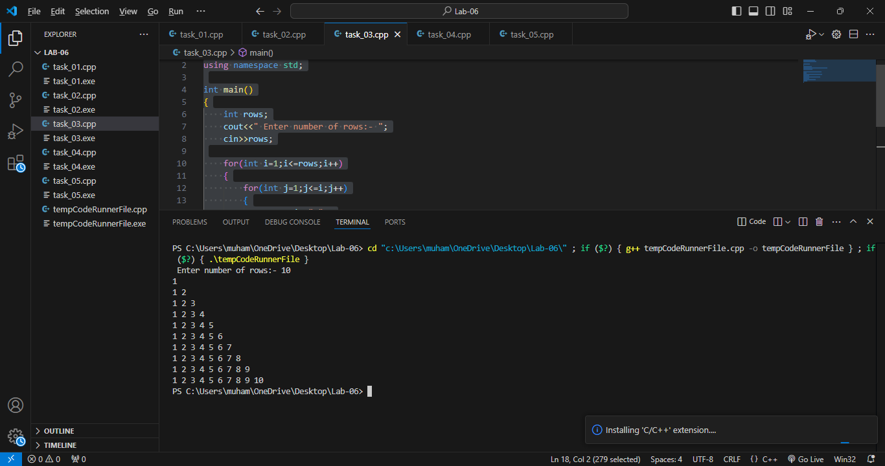

**Task 4:**

Create a program that outputs the days for a specified number of weeks. This will help you practice using nested loops in C++ and improve your understanding of iteration and output formatting:

**Code:**

|  |
| --- |
| #include <iostream>  using namespace std;  int main() {  int number = 3;  int days = 7;  for (int i = 1; i <= number; i++) {  cout << "Week " << i << ":" << endl;  for (int j = 1; j <= days; j++) {  cout << "\tDay " << j << endl;  }  cout << endl;  }  return 0;  } |

**Output:**

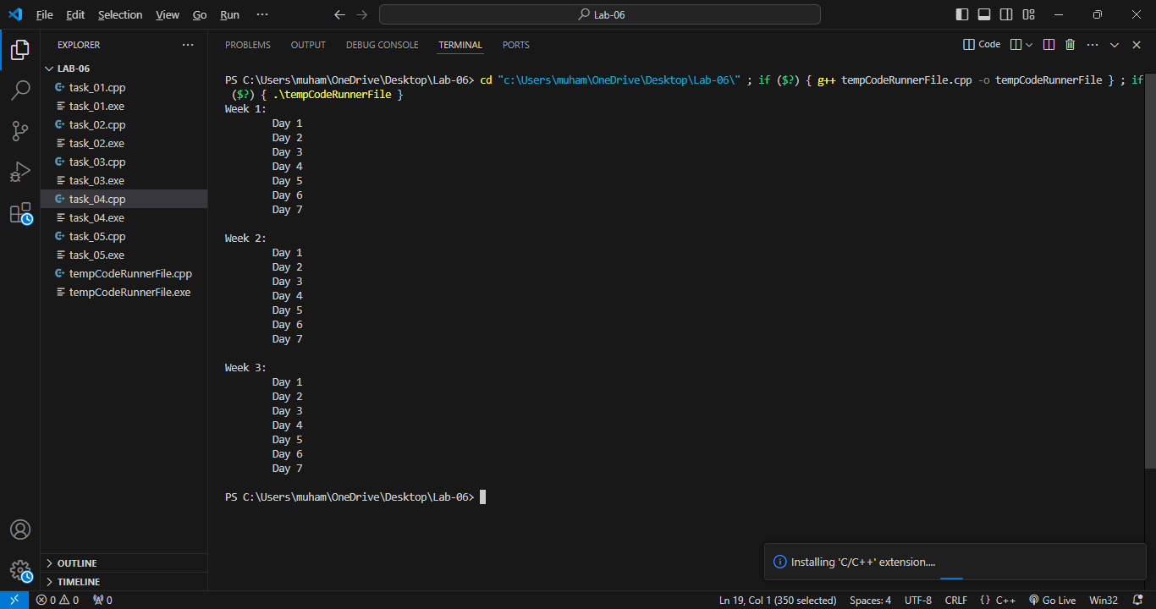

**Task 5:**

Let’s consider a seating arrangement in a theater. Imagine a theater with multiple rows of seats, where each row has several seats numbered from left to right. If we want to display the seat numbers in each row.

There are 5 rows and each row has 10 seats. A nested loop can help us print each seat's number in each row.:

**Code:**

|  |
| --- |
| #include <iostream>  using namespace std;  int main() {  int row = 5;  int seats = 10;  for (int i = 1; i <= row; i++) {  cout << "Row Number:- " << i<<"\t";  cout<<endl << "Seat: " <<endl<< "\t" ;  for (int j = 1; j <= seats; j++) {  cout << j << ",";  }  cout << endl<<endl;  }  return 0;  } |

**Output:**

